Advanced Functions and Modeling
Mountain Island Charter School
2016-2017
Teacher Name  Jeffrey Serra | Contact Information  Email:jserra@micharter.org  Website:serramath.weebly.com | Tutoring Availability  Monday through Thursday

Dear Parents and Students,

Welcome to Advanced Functions and Modeling! This class is a fourth level math class offered to students who need one more credit of math to graduate. This syllabus lays out everything you need to know about what this class is, how class runs day to day, and how grades will be administered. If you are a senior taking this class, I highly recommend that you read and follow the guidelines in this syllabus as my class is required for graduation. If you fail this class, you will not graduate. I look forward to working with you this year, and if you have any questions, please contact me using the contact information at the top of the syllabus.

Thank you,
Mr. Serra
---------------------------------------------------------------------------------------------------------------------

Purpose of the Course:
Advanced Functions and Modeling provides students an in-depth study of modeling and applying functions in a variety of real world problems. Students will use a variety of contexts to understand and apply the different functions including Polynomial, Rational, Exponential, Logarithmic, and Trigonometric. Students will also look at how to work with real data using statistical analysis

Units of Study:
- Understanding Patterns, Sequences, and Series
- Functions
- Power Functions and Polynomials
- Exponential Functions and Logarithmic Functions
- Piecewise Functions
- Right Triangle Trigonometry
- Trigonometric Functions
- Probability and Statistics

Structure of Class:
Class is divided into 3 sections: Warm Up, Activity, and Closing:
- At the beginning of class (first 10 minutes), students are required to complete the warm up activity that reviews either previous material covered or previous skills needed to understand the day’s material.
- The middle part of class consists of the activity for the day. This part of class begins with me introducing what we are doing, why we are doing it, and a short walk through on how to do it. Once initial questions are answered, the students are released to work on their own or with each other on the activity. Most activities require students to explore a concept by answering questions and justifying their answers mathematically using patterns, graphs, equations, or previous knowledge. During this period of exploration, I move from direct instructor to guide on the side. This means that I am walking around looking at student answers, clarifying student misunderstandings, and asking questions deepen student understanding. I do not do anything at the board unless I need to as the purpose of this time is for students to actively explore.
- At the end of class (last 15 minutes), we will come back together as a class, and I will summarize what concepts and skills we learned that day. Students will also take a ticket out the door to assess understanding.
The work done in class is highly important as it lays both the conceptual understanding and procedural understanding for the day. Students are responsible to complete all work and will be graded accordingly. If students choose not to do work in class, they are putting their understanding at risk, which puts their grade at risk.

Class Expectations:

The following are my expectations for every student:
- Making mistakes and talking about those mistakes is the cornerstone of my classroom. Being comfortable with mistakes is important for success in math but is unfortunately frowned upon in our society. Because most students are uncomfortable making mistakes, I ask students to be respectful of each other and not put other down because someone made a mistake or did something “dumb.” Instead, I expect encouragement or nothing at all. This means I do not need to hear profanity, any other derogatory language, or any put downs. I also ask that students are respectful of me because I am the leader of this classroom. If a student has an issue that is in relation to me, I ask that he or she talk to me about it in the hallway or quietly at my desk so the instructional time can continue without disruption. If a student decides to argue with me or use disrespectful language towards me, I will refer them to Mr. Humphrey for the rest of the period.
- Research is starting to show that phones even when used correctly are a huge distraction in the classroom. Because of this, phones will not be used in class and are expected to be silenced and put away during class. I strive to make sure I comply with my own phone rules. My phone will only come out if I need to get in contact with administration. I ask that parents please refrain from communicating with their child during class as it is a distraction. If parents need to get in contact with their child, please contact the school and the information will be relayed to the student in a non-distracted manner.
- The Chromebook will be used for some activities in this class. If we are using the Chromebook, students are expected to be on the website we are using and only the website we are using. If we are not using the Chromebook, students are expected to keep the Chromebook in their book bag.
- Being prepared, being on time, and being here for class are the most important expectations for this class. Students need to bring all supplies mentioned in the supply list below. Students need to be on time for class because when that bell rings, class starts and students will miss important information. Being here for class is the most important as each class period builds on the previous. If a student misses even a day, they will be missing important information from the day before.
- Students are only allowed to consume non-flavored, non-colored water in my classroom per the request from administration. Any other beverages and food will result in the appropriate consequences.
- Students are not allowed to sleep in class or put their heads down in class. If a student puts his/ her head down, they will receive a lunch detention and will be asked to stand up. If a student needs to walk around or get water to stay up, I ask they let me know.
- If students decide not to follow my expectations, the following are my consequences:
  - Lunch Detention with Parent Contact
  - After the 3rd lunch detention, Parent contact with Mr. Humphrey copied on the email.
  - After the parent email with Mr. Humphrey copied, I will write a written referral to Mr. Humphrey
  - If a student is being disruptive to the learning environment (arguing with me, throwing away the lunch detention, etc), students will be referred straight to Mr. Humphrey.
  - Most common infractions are usually food, cell phone use,

Supplies Needed by the Students:
- Ti 83 Plus or TI 84 Calculator REQUIRED
- 3 Ring Binder
- Loose Leaf Paper
- Graph Paper
- Pens and Pencils
- Dividers
- Chromebook

Resources Used for Class:
- Discovering Advanced Algebra
- Algebra II Textbook s
- Teacher Generated Lessons
- Online Resources

How Students will be Assessed:
This year I will be implementing a modified Standards Based Grading. Standards Based Grading is a system where students are graded on mastery of the content. At the end of each week, students will be given a small quiz to assess mastery of the material covered for that week, and the score on that quiz will determine the level of mastery. At the end of the unit, students will take a unit test, and the score on that unit test will determine level of mastery for the unit. The following is my scale with gradebook conversion and description.

5: 100 (Master: Demonstrates an understanding of the concept and error-free computations)
4: 80 (Expert: Demonstrates an understanding of the concept and minor computational errors)
3: 70 (Practitioner: Demonstrates a basic understanding of concepts and average computational errors)
2: 60 (Apprentice: Demonstrates a limited understanding of concepts and has major computational errors)
1: 50 (Novice: Demonstrates little to no understanding of concepts and has major computational errors)

How Students will be Graded:
Category | Assignments | Weight
Formal | Mastery Quizzes | 40%
Informal | Quiz Corrections, Projects, and Benchmarks | 40%
Employability | Effort Grades and Homework | 20%

Types of Assignments:
Quizzes and Tests:
- Students will be given a weekly quiz to assess mastery of the material covered for that week. These quizzes will have open ended problems where students have to find an answer and justify how they got their answer.
- Students will have a unit test at the end of each unit to assess mastery. These tests are cumulative and will feature questions related to material from previous units. Unit Tests will have a mixture of multiple choice and free response.
Homework:
- Students will be given IXL homework on a weekly basis. At the beginning of the week, students will be given their homework, and it will be due at the end of the week. Students who complete the homework will receive a 100 in the gradebook.

Classwork:
- Students are expected to complete all notes and classwork in class. Students are expected to keep all work done in class in their notebook, and at the end of each week, students will have a notebook check to hold them accountable for the work done in class.
Projects:
- Students will have the occasional project to extend and apply what we are learning in class. Projects can range from group presentations to individual essays on a certain topic.

Quiz and Tests Corrections
- Success and mastery in math requires students to reflect upon their mistakes and understand what they did wrong. To help them achieve this, students are encouraged to come in and do quiz corrections. If students complete the quiz corrections correctly, they will have the opportunity to come and retake the quiz to improve their mastery score. The highest score will go into the gradebook. All quiz corrections for previous quizzes must be done before the next quiz.
- On the day after each unit test, students will be given the opportunity to do unit test corrections in class. Students will not be able to improve their unit test scores, but they will get a separate grade in the gradebook for their test corrections. All Unit Test Corrections must be done in class and turned in by the end of class for credit.

Late Work:
- Projects: If a student does not turn in a project, they can turn it in by the beginning of the next class period for up to a 80%. After this “24 hour” grace period, projects will not be accepted late.
- Classwork: Classwork is not accepted late.

Make Up Work:
- Classwork: Students are expected to complete all classwork if they are absent. Students will have access to all assignments with answers on my website.
- Quizzes: If a student is absent the day of a quiz, they are responsible for scheduling a time before the next quiz to make up the quiz they missed. If students miss a quiz, a grade of “0” will stay in the gradebook until the quiz is made up. If the quiz is not made up, the grade of “0” will remain and can only be changed if students do quiz corrections and come in to do a retake quiz.
- Benchmarks: If a student is absent the day of a benchmark, they will need to schedule a time to complete the benchmark. Students will have a week to take the benchmark, and until it is made up, the grade of “0” will appear in the gradebook.

Tutoring Policy:
- I hold tutoring on Thursday of every week at 2:30 and ending at 3:15. My expectations for tutoring are as follows: students must be on time, students must be prepared with material to work on, and students must not be disruptive. If a student does not adhere to my expectations, he or she will not be allowed in the tutoring session.

Academic Honesty and Cheating
Students are expected to sustain academic integrity and not cheat on assignments. If a student is suspected of cheating, the following will happen:
- If cheating occurs on an assessment, the student will be referred to Mr. Humphrey for further consequences. A grade of “0” will also be entered in the gradebook.
- If cheating occurs on a project or outside assignment, the student will be referred to Mr. Humphrey for further consequences. A grade of “0” will also be entered in the gradebook.

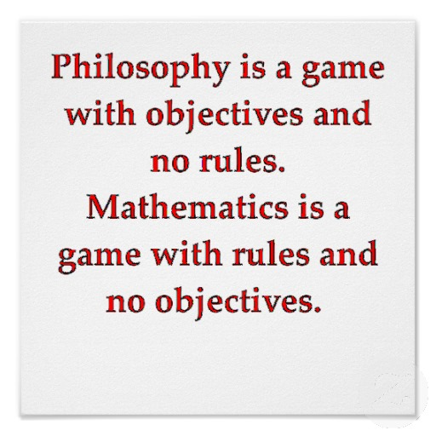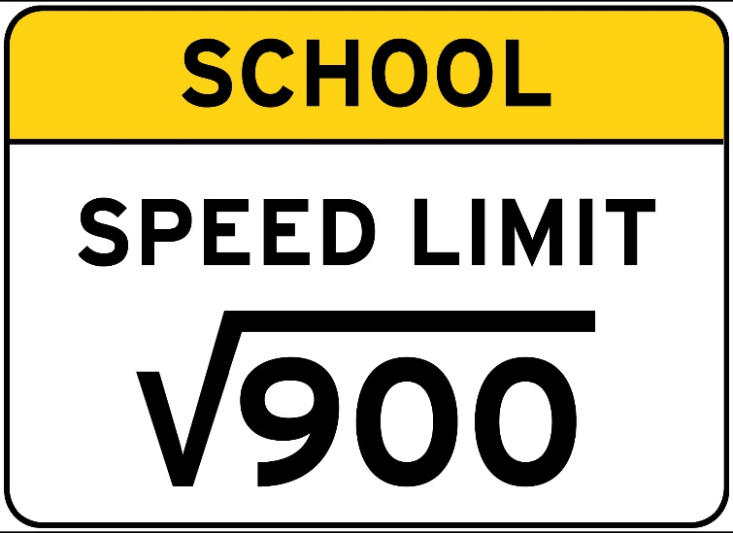

Please complete the box below and return by September 1st.
Parent Signature: ____________________________________________________________
Parent Email: ______________________________________________________________
Student Signature: _______________________________________________________
Student Email: ______________________________________________________________

